**Back up plans**

Navigate to the AWS Backup console, first we need to create a BackVault to store backup.

Provide the vault name and kms key for encryption and create the vault.

Next create Back plan

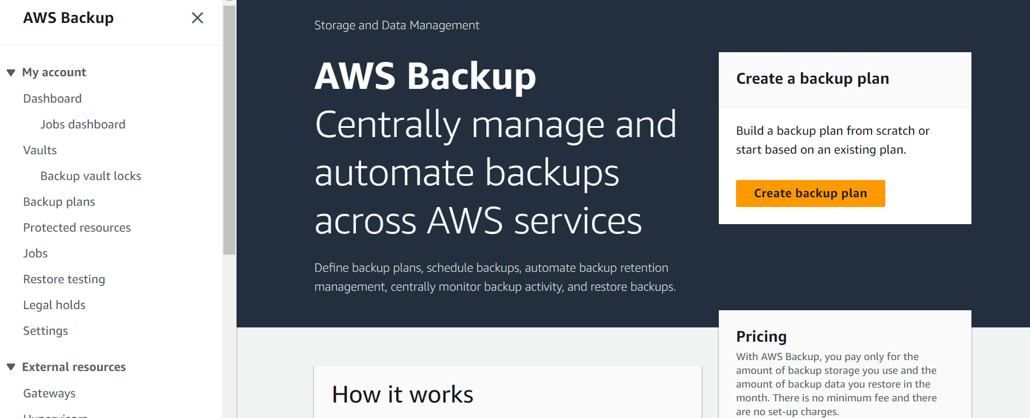

While creating backup plan select Build a new plan and give a name.

Configure the Back rule provide the Back up Vault we create earlier and back up frequency as daily or weekly or monthly based on requirements.

Specify the Backup Window for taking the backup

Specify the retention period to keep the backup

Create the plan

Once plan is created window will appear to add the resource for which back up need to be taken.

Select the specific resources for example here we are taking EC2 instance backup and select the specific instances to take back up.

Click on Assign resources

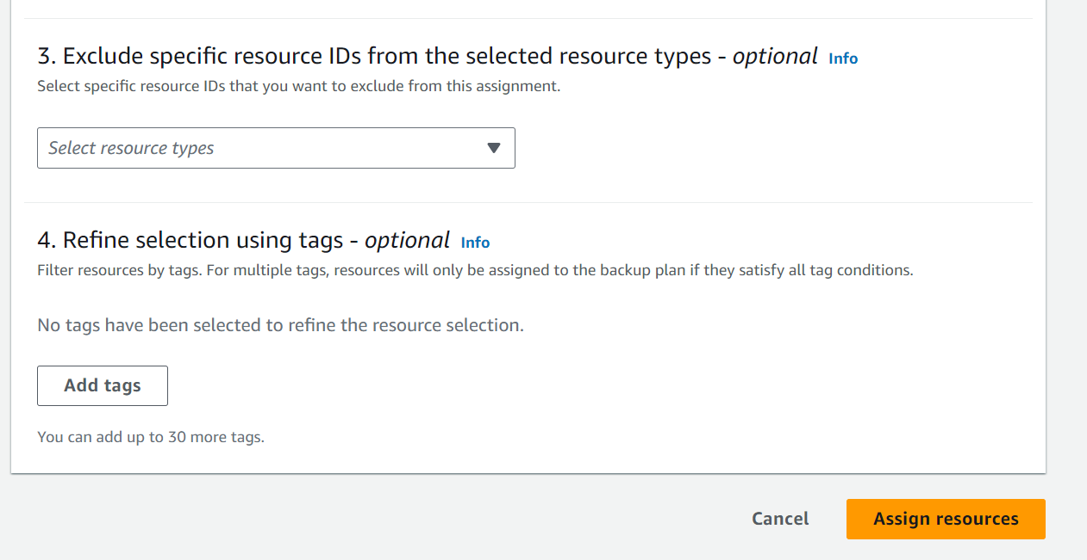

Once the plans are created it will visible like this:

Once the back plan takes the back up we can see this as jobs :

For restoring select the Restore testing and select the image to restore and click on restore.

